# Intermediate Spreadsheets.

#### What's in a cell?

In which you learn to interrogate cells to determine the data type of their contents, and to convert between data types.

**Data Types for data science**

## 1. [1.] Data types for data science [Veri bilimi için veri türleri]

Hi, I'm Richie, a Data Evangelist at DataCamp. [Merhaba, ben Richie, DataCamp'ta Veri Evangelistiyim.] The main purpose of this course is to expand your spreadsheet vocabulary. [Bu kursun temel amacı elektronik tablo kelime dağarcığınızı genişletmektir.] You're going to see a lot of new functions that will come in handy in future courses. [Gelecekteki kurslarda kullanışlı olacak birçok yeni fonksiyon göreceksiniz.]

## 2. [2.] Calculating the mean, badly [Ortalamayı hesaplamak, kötü]

Let's start with an easy problem, calculating the mean of 5 numbers. [5 sayının ortalamasını hesaplayan kolay bir problemle başlayalım.] You type equals to denote a formula, call the AVERAGE() function, and pass it the range of cells containing the numbers. [Bir formülü belirtmek için eşittir yazar, ORTALAMA() işlevini çağırır ve ona sayıları içeren hücre aralığını iletirsiniz.] Unfortunately, something's gone wrong. [Ne yazık ki, bir şeyler ters gitti.] The answer ought to be about 33, not 34. [Cevap yaklaşık 33 olmalı, 34 değil.] Pause the video and see if you can spot what the problem is. [Videoyu duraklatın ve sorunun ne olduğunu tespit edip edemeyeceğinize bakın.]

## 3. [3.] What went wrong? [Ne yanlış gitti?]

Did you find the problem? [Sorunu buldunuz mu?] In the fourth number, at the sixth decimal place, a number one is actually the letter "I". [Dördüncü sayının altıncı ondalık basamağındaki bir sayı aslında 'I' harfidir.] That means that the spreadsheet ignores that cell when it makes the calculation. [Bu, elektronik tablonun hesaplamayı yaparken o hücreyi yok saydığı anlamına gelir.]

## 4. [4.] Please don't stare! [Lütfen bakma!]

When you only have five rows of data, it isn't too tricky to locate the problem. [Yalnızca beş satır veriniz olduğunda, sorunu bulmak çok zor değildir.] If you have five thousand rows of data, it's much harder. [Beş bin satırlık veriniz varsa, bu çok daha zordur.] If you have to stare at every single cell in a workbook that big, you'll quickly go spreadsheet-blind. [O kadar büyük bir çalışma kitabındaki her bir hücreye bakmanız gerekiyorsa, hızla elektronik tablo körü olursunuz.]

## 5. [5.] The 4 common data types [4 yaygın veri türü]

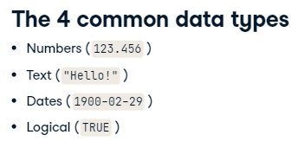

Before we get to the solution, let's quickly take a look at the most common types of data that you'll encounter in a spreadsheet. [Çözüme ulaşmadan önce, bir elektronik tabloda karşılaşacağınız en yaygın veri türlerine hızlıca bir göz atalım.] There are only four of them, namely numbers, text, dates, and logical. [Bunlardan sadece dördü vardır, yani sayılar, metin, tarihler ve mantıksal.] Logical data contains TRUE and FALSE values. [Mantıksal veriler DOĞRU ve YANLIŞ değerleri içerir.]

## 6. [6.] ISNUMBER() checks if a cell contains a number [ISNUMBER() bir hücrenin sayı içerip içermediğini kontrol eder]

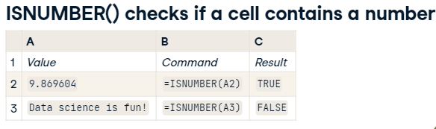

You can test for different types of data using functions that begin with "IS". ['IS' ile başlayan işlevleri kullanarak farklı veri türlerini test edebilirsiniz.] For example, ISNUMBER() takes a cell location as an input, and returns TRUE if that cell contains a number, and FALSE otherwise. [Örneğin, ISNUMBER() bir hücre konumunu girdi olarak alır ve bu hücre bir sayı içeriyorsa DOĞRU, aksi takdirde YANLIŞ döndürür.] This allows you to be sure that your cells contain the type of data that you thought they did. [Bu, hücrelerinizin, içerdiğini düşündüğünüz veri türünü içerdiğinden emin olmanızı sağlar.]

## 7. [7.] Other "IS" functions for checking types [Tipleri kontrol etmek için diğer 'IS' işlevleri]

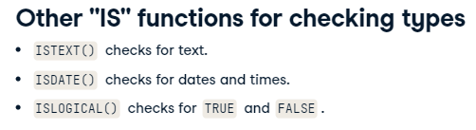

Similarly, ISTEXT() checks for text data, ISDATE() checks for date data, and ISLOGICAL() checks for logical data. [Benzer şekilde, ISTEXT() metin verilerini, ISDATE() tarih verilerini ve ISLOGICAL() mantıksal verileri denetler.] Easy! [Kolay!]

## 8. [8.] Checking cell properties and rarer types [Hücre özelliklerini ve daha nadir türleri kontrol etme]

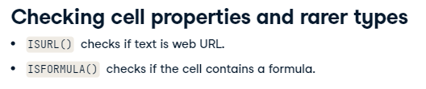

In addition to checking for the four common data types, there are some other checks that you will encounter in this chapter. [Dört yaygın veri tipini kontrol etmenin yanı sıra, bu bölümde karşılaşacağınız başka kontroller de var.] You can check if the text in a cell is a web address using ISURL() and you can check for formulas using ISFORMULA(). [Bir hücredeki metnin bir web adresi olup olmadığını ISURL() kullanarak kontrol edebilir ve ISFORMULA() kullanarak formülleri kontrol edebilirsiniz.]

## 9. [9.] Copying formulas between cells [Hücreler arası formül kopyalama]

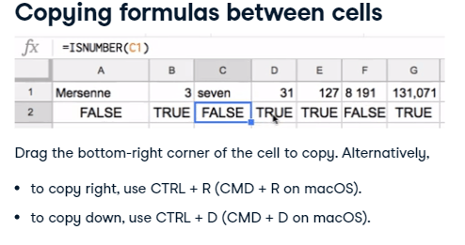

One Google Sheets technique that you need to know throughout this course is how to copy a formula across cells. [Bu kurs boyunca bilmeniz gereken bir Google E-Tablolar tekniği, bir formülü hücreler arasında nasıl kopyalayacağınızdır.] When you select a cell, it has a blue square in the bottom-right hand corner. [Bir hücre seçtiğinizde, sağ alt köşesinde mavi bir kare bulunur.] Click that square and drag it to copy the formula to new cells. [Formülü yeni hücrelere kopyalamak için o kareye tıklayın ve sürükleyin.] Alternatively, you can select both the cell containing the formula and the cells that you want to copy to and press Control and "R" to copy right, or Control and "D" to copy down. [Alternatif olarak, hem formülü içeren hücreyi hem de kopyalamak istediğiniz hücreleri seçip sağa kopyalamak için Control ve 'R' tuşlarına veya aşağı kopyalamak için Control ve 'D' tuşlarına basabilirsiniz.] If you use macOS, the equivalent commands are Command and "R", or Command and "D". [macOS kullanıyorsanız, eşdeğer komutlar Komut ve 'R' veya Komut ve 'D'dir.]

## 10. [10.] Let's go! [Hadi gidelim!]

Alrighty! [Pekala!] Let's get started! [Başlayalım!]

#### (1) What IS*() the data type?

The values contained in each cell (either the things you typed, or the results of formulas) have a **data type**. Common types include number, text, date and logical.

Sometimes it is useful to check what type of data you have in each cell, since it may not be obvious just from looking at it. Google Sheets has a series of functions with names beginning "IS" that perform these checks, for example, [**ISTEXT()**](https://support.google.com/docs/answer/3093297) takes a cell address like B3 as an input, and returns the logical value TRUE if the cell contains text, or FALSE otherwise.

Likewise, [**ISNUMBER()**](https://support.google.com/docs/answer/3093296) checks for numbers in the cell, ISDATE() checks for dates, and [**ISLOGICAL()**](https://support.google.com/docs/answer/3093351) checks for logical values.

The worksheet shows data taken from Wikipedia regarding [**men's 100m sprint world records**](https://en.wikipedia.org/wiki/Men%27s_100_metres_world_record_progression#Records_from_1977).

##### Instructions

Check the data types of the first row of sprint data. In cell A21, there is a formula to check if the value in A2 is numeric.

* Copy the formula right as far as G21 by dragging the bottom-right corner of A21.
* In cells A22 to G22, check if the values in cells A2 to G2 are text by writing formulas that call ISTEXT().
* In A23 to G23, use ISDATE() to check if A2 to G2 are dates.
* In A24 to G24, use ISLOGICAL() to check if A2 to G2 are logicals.

#### (2) Checking rarer data types

Google Sheets also allows checks for rarer data types beyond number, text, date, and logical. In this exercise you'll use [**ISURL()**](https://support.google.com/docs/answer/3256501) to check for website URLs, and [**ISFORMULA()**](https://support.google.com/docs/answer/6270316) to check for cells that contain formulas.

ISURL() checks that the text in a cell takes the form of a URL. This includes text that starts with a protocol, like http://, ftp:// and mailto:, and guesses at other text like somewebsite.com.

To make the text into a clickable hyperlink, use HYPERLINK(). This takes the address of a cell containing a URL and optionally the address of a cell containing the text to display, for example HYPERLINK(A1, B1).

ISFORMULA() takes the address of a cell and returns TRUE when that cell contains a formula. For blank cells and cells with fixed values, it returns FALSE.

##### Instructions

The column "Olympic team site" contains a URL to the Olympic team for the athlete's nation. In cell I2, there is a formula to create a hyperlink to the USA site.

* Copy the formula in I2 down as far as I20.
* In cell A21, use =ISURL(A2) to check if this is a URL.
* Copy this formula right as far as I21.
* On row 22, use =ISFORMULA() to check if the cells from A2 to I2 contain formulas.

#### (3) Finding missing data

ISBLANK() accepts a cell address and returns TRUE if that cell is empty. This provides a useful way of checking for missing data.

Logical conditions like ISBLANK() are useful for filtering datasets: you can keep only the rows where some condition is TRUE. Data filtering can be done using [**FILTER()**](https://support.google.com/docs/answer/3093197), which takes two arguments. The first argument is the range of the data that you want to filter, and the second argument is the range containing the logical values to filter on.

For example, if the data (not including the header row) is in A2:E10, and the final column E contains the logical values to filter on, you would type =FILTER(A2:E10, E2:E10).

##### Instructions

Some athletes have gone missing! An extra column, "Athlete Is Blank?" has been added to the dataset.

* Use the ISBLANK() function in column H to determine which values in the dataset have missing athletes.
* In cell A23, call FILTER() to filter the dataset to show only the rows with missing athletes.
  + Pass the range of all the data from A2 to H20 as the first argument.
  + The 2nd argument should be the logical values contained in H2 to H20.

Mind-blowing missing data detection! `ISBLANK()` combined with `FILTER()` is a powerful way to find missing data.

#### (4) Dteectnig bdaly tpyed dtaa

One of the sad realities of being a data scientist is that you get handed a lot of awful datasets. If data has been manually entered, then it is really common to have typos, which can give the data the wrong type! You can use the IS functions to detect if your data has been correctly entered.

ISDATE() accepts a cell address and returns TRUE if that cell contains a date.

##### Instructions

* In cell H2, check if the corresponding Date really is a date.
* Copy the formula down the column.

Hot date action! The `IS*()` functions provide a way to programmatically check that your data has the type that it ought to.